**Cash Management - Documentation**

### **Custom DocTypes**

#### **Petty Cash Management (Parent DocType)**

* Fields:
  + Company: Link to the Company for which the transaction is recorded.
  + Cost Center: Link to the Cost Center associated with the transaction.
  + Posting Date: Date of the transaction.
  + Employee: Link to the Employee involved in the transaction.
  + Cash Accounting Ledger: Link to the Cash Ledger for accounting purposes.

#### **Petty Cash Expense (Child DocType)**

* Fields:
  + Supplier: Link to the Supplier related to the expense.
  + Expense Accounting Ledger: Link to the Expense Ledger for accounting purposes.
  + Remark: Description or notes related to the expense.
  + Amount: Amount of the expense incurred.

### **Child Table**

The Petty Cash Management DocType includes a child table for recording Petty Cash Expenses. This allows for detailed tracking of individual expenses associated with each petty cash transaction.

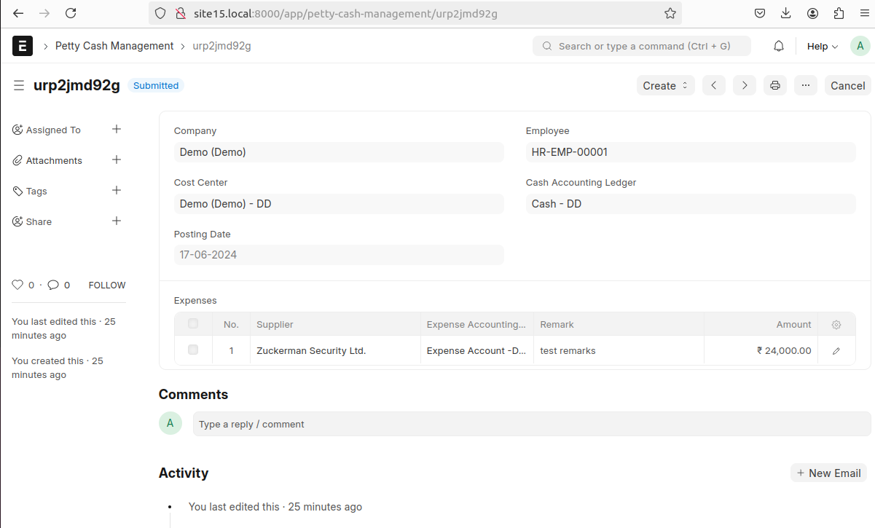

### **Filters**

* JavaScript Filters:
  + Active Employees: Filter to display only active employees in the Employee field.
  + Cash Ledgers: Filter to display only Cash Ledgers in the Cash Accounting Ledger field.
  + Expense Ledgers: Filter to display only Expense Ledgers in the Expense Accounting Ledger field within the child table.

### **Custom Button**

A custom button is implemented in the Petty Cash Management DocType to create a Journal Entry. This button is visible only when the document is submitted, ensuring that Journal Entries are created only for approved transactions.

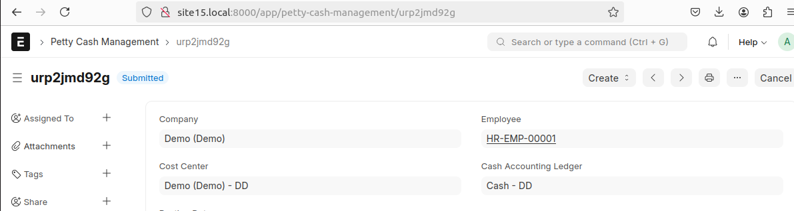

### **Python Function**

When the custom button "Create Journal Entry" is clicked, a Python function is invoked to create a Journal Entry based on the submitted Petty Cash Management document.